Data Storage

System requirements

Relational Database Management System

MySQL or PostgreSQL are two of the most widely used open source relational database management systems. PostgreSQL has the PostGIS extension that enables the database to act as a component of a Geographical Information System (GIS).
In terms of operational complexity both systems offer similar operational complexity. Choosing one or the other system will depend on the existing infrastructure available.

Operating System

When possible use a Linux based operating system, e.g. Ubuntu Linux, Debian, CentOS

Data security

Encryption at rest

The operating system should be enabled with encryption at rest.

Encryption in transit

The communication channels should use encryption to transmit information. The most common and easiest solution is to use TLS/SSL encryption between client and server. Free alternatives like Let’s Encrypt, offer an easier way to comply with this requirement.

Data model
Based on the current structure for information storage and reporting, the entities can be classified in "definitions" and "reports".

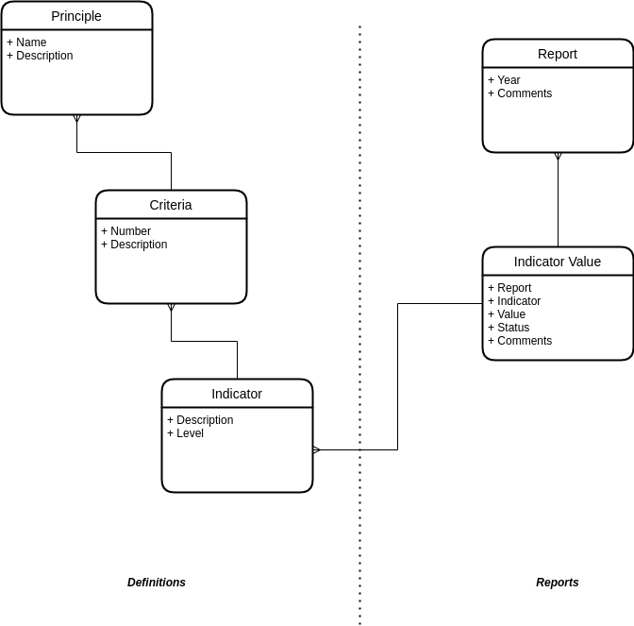

The definitions hold information about the REDD+ principles that do not change, this include "Principles", "Criterias" and then "Indicators".

The monitoring of activities happens associated with a "Report" where we link the Indicators to a yearly "Report".

Data management protocol

Introduction
This protocol covers the management of data for Fiji's REDD+ Safeguard Information System (SIS).

Purpose of this document
This document outlines procedures for utilizing the data collected for reporting on indicators for each one of the Principles and Criterias for REDD+. Specifically, the document aims to do the following:

- Ensure the accuracy of the data for reporting
- Describe the process for data use by stakeholders
- Describe a process for data use by external users
- Recommendations on how to handle data collection for indicator reporting

Accuracy of data
Based on the list of sources for information, extra care needs to be taken in regards to the accuracy of data for reporting on indicators. The current list of systems includes:

- Fiji Redd+ Portal
- Ministry of Forestry Website
- Climate Change Portal
- Ministry of Environment Website
- VanuaGIS
- National Forestry Monitoring System (NFI)
- NFMS (Policies and Measures)
- NFMS (Permanent Sample Plot)
- Timber Revenue System (TRS)
- Timber Import Licensing System
- Forest Export Monitoring System
- iTLTB Website
- LandSoft
- Qele Maroroi View
- iTLTB Complaints Management System
- Equal Lease Distribution System
- Ministry of Agriculture Website
- Ministry of Lands Website
- VKB
- IVDP
- Village Profiling System

Data collection for reporting
The information about the different indicators is spread across different systems. The return on investment (ROI) when trying to automate the synchronization of data between the different systems is really low. There is no standardized protocol for data synchronization. Just this process can take from a few months to a couple of years.

Our recommendation is to use a manual process for collecting the different raw values from the different systems in a standardized way.

The current value of a given indicator contributes to the "Addressed" or "Respected" status of a REDD+ criteria. A sample template for collecting the value, validating and reporting

Report | Indicator | Value | Status
Date | Collected by | Signature
Date | Signed by | Signature

Example:

Report: 2022 | Indicator: Assesses the contribution of REDD+ activities to the overall budget based on NDP and GGF | Value: High | Status: Addressed
Source: | National Budget based on NDP and GGF
2022-01-15 | Collected by: David Cahn (fictitious) | Signature:
2022-01-30 | Validated by: Emeline Smith (fictitious) | Signature:

Data use by Stakeholders

The reports about the indicators will be linked from the Ministry of Forestry website to the REDD+ Fiji reports. A temporary prototype implementation is located at: https://fiji-sis.tc.akvo.org
The code repository of the initial prototype can be found at: https://github.com/akvo/fiji-sis

Data custodian
The Ministry of Forestry Republic of Fiji will be responsible for the data. The database management system and supporting program will be managed by an assigned Data Manager who will input the collected data when authorised and keep a log of changes to the indicator values.

